Social Media Template to share:
Do you know how to obtain your free proof of your COVID-19 vaccination, and how to help customers, family and friends get theirs?

Your COVID-19 digital certificate and immunisation history statement both show proof of your COVID-19 vaccination status in Australia.

The quickest and easiest way for you to get proof of your COVID-19 vaccination is by downloading the Express Plus Medicare app. All you need to do is make sure you have a myGov account set up with Medicare linked.

The Express Plus Medicare app will allow access to:
- your or your child under 14 COVID-19 digital certificate
- your or your child under 14 immunisation history statement
- add your COVID-19 digital certificate to your state check in app
- VIC, NSW, NT, ACT, QLD and TAS are live
- More states to be announced
- and, save your International COVID-19 Vaccination Certificate offline
If you are unable to obtain your proof of COVID-19 vaccination online, you can ask your vaccination provider to send you a copy or you can ring the Australian Immunisation Register on 1800 653 809.

For more information please go to the Services Australia website or click on these links:
- Do you need to show proof of your COVID-19 vaccinations? - Services Australia
- Save your proof of COVID-19 vaccinations offline - Services Australia
- Getting help during coronavirus (COVID-19) - How to get proof - Services Australia

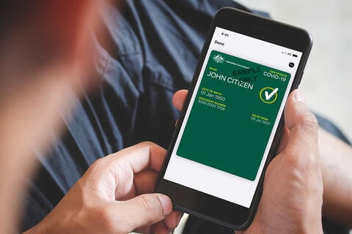
Image available from: Services Australia

