We have created a template for tracking attendance at training using Google Sheets. When you click on the below link, you will be asked if you would like to create a copy of the Google Sheet. This copy will become your club’s document for tracking, and we ask that you give relevant staff members access (explained below).

Click link below to access the template and click Make a copy
https://docs.google.com/spreadsheets/d/1v_HgHvICx4ySnMnH2OHc8lR1U5bieFHXPMuJQUpk2_A/copy
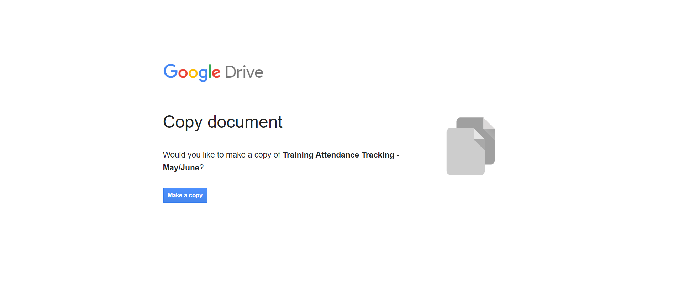

Rename the document by clicking on the title and then adding your club name before Training Attendance.
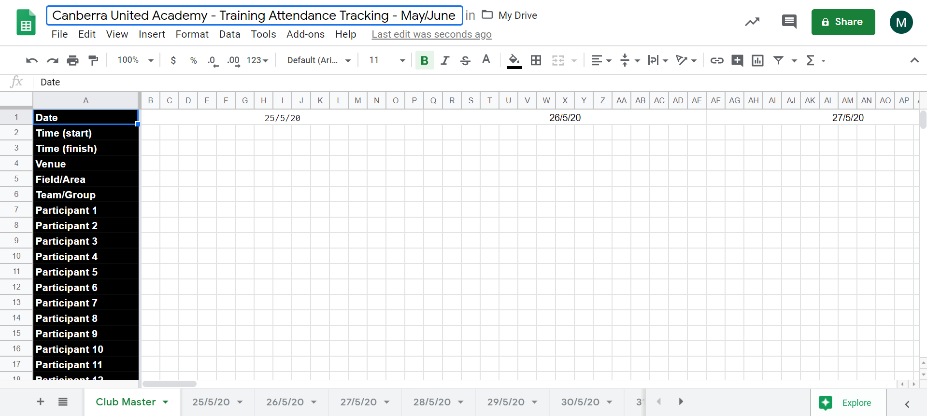

The document is set up with different sheets for each date, and the data will automatically fill through to the Master sheet at the start
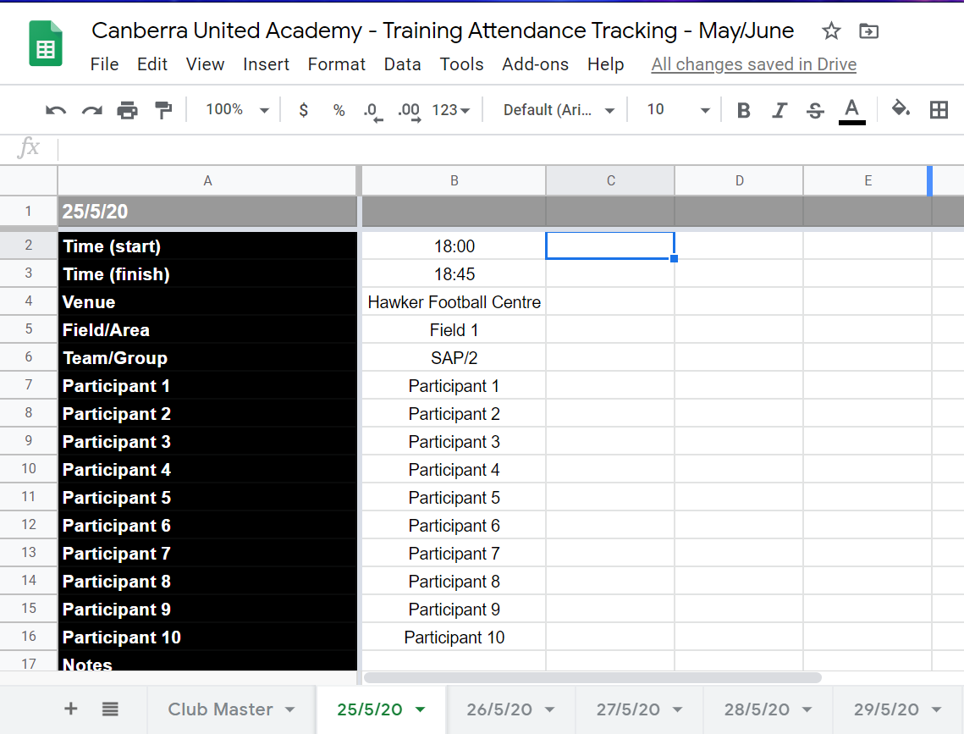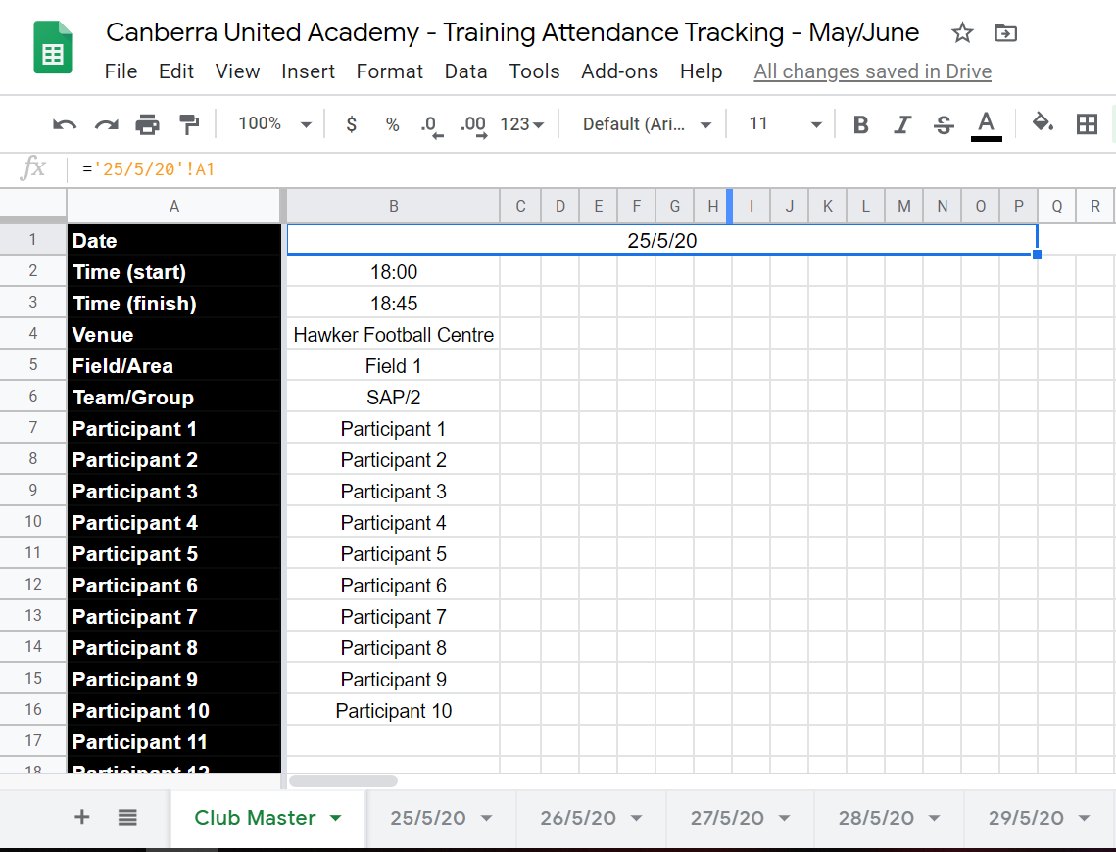

So that Capital Football are able to assist with tracking and help with any issues, please give access to Kelly Stirton (kelly.stirton@capitalfootball.com.au) by clicking the green Share button in the top right hand corner and then entering the email address.
You can share the document with other club staff this way, or you can also click “Get shareable link” and pass that link on to people.
