On The Attack: A Goal Scoring Analysis

Wednesday November 6

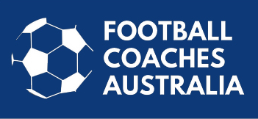

On The Attack: A Goal Scoring Analysis
Presented by Dr Ron Smith and Heather Garriock
Date: 6 November 2019 @
Venue: The Rex Hotel
Registration link: http://education-ffa.sportingpulse.com/Entry/?EID=21067

Football Capital and Football Coaches Australia is pleased to present On The Attack: A Goal Scoring Analysis workshop.
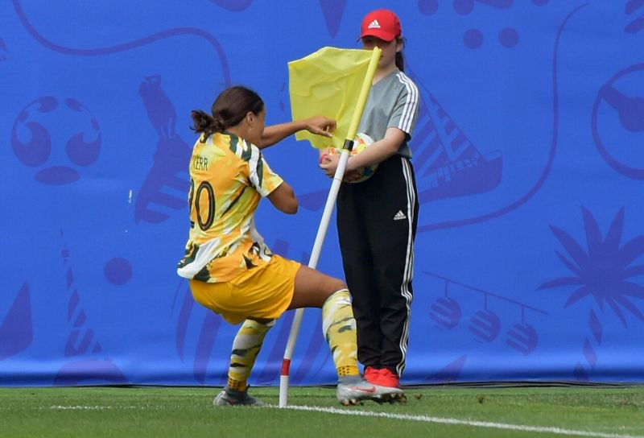

Attendance at this workshop will count for 10 FFA Accreditation CPD points.

Learn how teams in the modern game score and create chances on regaining possession in each third of the field and, in particular, the final third.
What's the evidence?
How can we use it?
What are the implications for session design and practice?
This workshop provides coaches with a unique opportunity to come together and discuss this exciting area of our game.
Get ready for what will be a fantastic evening .
Join Football Coaches Australia (FCA) Ambassador Dr Ron Smith, a legendary developer of players and coaches alike, as he leads this workshop and explores the strategies and tactics used by top teams to score.
Ron will explore the art of scoring goals using data from the Men's and Women's World Cups and how Australia's record compares to other teams, with particular reference to goals scored and attempts at goal in "open play".

Heather Garriock, (Canberra United Head coach, FCA Vice President, Matildas Assistant Coach and Optus Football Commentator) will also provide her insights into the discussion.
So, if you're a community or advanced coach and want to learn more about finishing the attack and the strategies used by leading teams we thoroughly recommend you join us for what should be a great 90 minutes of insight and discussion.
